

**Women Empowerment: *Having a voice in society & influencing policy***

Qurratul Ayen Elma - 20201121

Section: S24

EMB101: Emergence of Bangladesh

Date: 28 / 08 / 2021

**Brac University**

Introduction:

Have you ever imagined a society without women? Don’t you think, lately, "discrimination" is being replaced with "Women's discrimination"? Understandably, the lands themselves include agricultural lands, wetlands, pastures, rangelands, fishing, forestry, and harvesting and hunting grounds. Because of practicing gender discrimination, the unequal distribution of land among family members means that women have less authority over land ownership. Throughout this paper, the phrase "women's rights to land" refers to a woman's authority to own, govern, purchase, control, sell, inherit, and make different choices about the property and associated resources, as well as her independence to obtain property rights. This thesis aims to discuss and address the discrimination against female rights in Bangladesh to access, utilize, acquire, manage, and inherit the land and the challenges that they are facing during this process, overlooking the observation of the fact to examine aspects of women's rights, both religion and patriarchal culture prospects. Other pieces of legislation, such as marriage law and family law, also apply to the protection of women's property rights. Land policy refers in general to agreements, principles, or guidelines that support land management and decision-making. Land-use planning generally refers to the activities or functions undertaken to implement land laws and policies, often by specific implementing institutions.

Even in countries with good legislation, women often do not have access to and control over productive resources. Implementation is too often impeded by socio-cultural norms and a lack of awareness of women's rights (UN Women, 2009).

Continued efforts are required to encourage gender-sensitive legislation, apply existing legislation, make judicial systems more accessible and responsive to women, and provide legal aid to women seeking to claim their rights (UN Women, 2009).

REGIONAL LEGAL AND POLICY FRAMEWORKS

Some of the human rights principles and standards relevant to women’s access to, use of, and control over land and other productive resources are universality and inalienability **(UNFPA, 2005)**, equality and non-discrimination, participation and inclusion, empowerment, and sustainability.

* Universality and inalienability

“All human beings are born free and equal in dignity and rights,” as expressed in article 1 of the Universal Declaration of Human Rights, and people of all over the world have the right to persist in the law. They cannot be freely given up by the individual to whom they belong.

* Equality and non-discrimination

All people are equal and have the right to exercise their human rights concerning land access, use, and control, regardless of race, color, sex, ethnicity, age, language, religion, political opinions,etc. States shall take all necessary steps to eradicate discrimination against women in terms of access to, use of, and ownership of land and other productive resources, including temporary special measures **(UN Humans Rights & UN General Assembly, 1979).**

* Involvement and inclusiveness

To achieve human rights, everyone has the right to active, free, and meaningful participation in, contribution to, and enjoyment of civic, economic, social, cultural, and political development. Both women and men should have equal access to information and meaningful consultation and involvement in decision-making processes related to land access, use, and control.

* Empowerment

The foundation of a human rights-based strategy is the empowerment of women and men to assert their rights. States must take all necessary steps to empower women so that they can exercise their human rights to access, utilize, and control land and other productive resources on an equal footing with men.

* Sustainability

Infrastructure and procedures important to the achievement of human rights must be resourced and maintained for sustainability. In terms of land, environmental preservation is inextricably linked to sustainability.

1. OVERARCHING ISSUES AND PRACTICES:

* Ensure participation of women in decision-making:
* *National Constitution should:*
* Ensure that women and women's rights groups/collectives are effectively represented on equal terms like land and agriculture, etc.
* Ensure that women and women's rights organizations/collectives receive complete and accurate information regarding land and agriculture decision-making processes and that they may benefit from capacity-building in this area.
* Ensure that women's equal access to, use of, and management of productive resources, including land, is explicitly acknowledged.
* Recognize women’s land, housing, and property rights.

When laws and policies related to these rights are harmonized and comprehensive, women's rights to access, utilize, and control land and other productive resources are best safeguarded.

2. SECURITY OF TENURE AND PROHIBITION OF FORCED EVICTION

* *Women’s right to legal security of tenure :*

When taken as a whole, several elements can help women acquire their land rights. Every aspect of this continuum can guarantee the right of women to land, provided that discrimination is prohibited and that women are admitted to ensure the legal certainty of the occupation.

* *Forced evictions against women:*

Forced evictions are described as the removal of people, families, and/or communities against their will from the homes and/or land they inhabit, without the provision of, or access to, sufficient legal or other protection. Property snatching or disinheritance by private actors can also be regarded as a kind of forced eviction committed against women. Any person who illegally deprives a legitimate successor of his assets is liable to criminal charges. Women's rights in the context of eviction and displacement are further protected by guidelines on development-based evictions and displacement.

3. ACCESS TO JUSTICE

* *Access to justice and enforcement:*

Religious and customary judicial authorities should be educated on women's rights. They should also support community-led paralegals, watchdogs, land tribunals, and other community actions that encourage women's leadership and equal access to land and other resources. This may also help women understand the land application process. To further promote and defend women's land and property rights, governments and others should directly help local efforts. Laws, regulations, and programs should gather gender-sensitive and sex-disaggregated data on land access, usage, and control, as well as data on other relevant grounds, such as gender and indigenous identity or gender and disability. Women's rights must be considered in the formulation and implementation of all laws, policies, and initiatives relating to productive resources and land, including monitoring and assessment.

**\*\*\*\*Intro te j gender discrimination er kotha bolsilam oita relate korte bolsilo tai eita likhsilam**

4. MARRIAGE AND FAMILY

* *Marital property rights:*

The position of women's rights to land and other productive resources is complicated by the question of marital property. Individually spouses are authorized to use the joint property when required, and the joint property can only be sold or given with the approval of both spouses.

* *Abolition of conjugal power and the concept of "head of household":*

Discrimination against women, including the provision or allocation of land and other productive resources in favor of male "heads of household," and ensuring that single female heads of households may access land rights on an equal basis through temporary special measures. According to the FAO, “... While establishing the family as the beneficiary unit and giving land titles to the (male) household head may still offer female household members access to land, they may weaken their negotiating power – and therefore their social standing **(FAO, 2007).**

* *Divorce:*

Laws, policies, and programs should ensure equal land and property rights for men and women in the event of divorce and dissolution of marriage.

5. LAND TENURE, POLITICS AND PROGRAMMING

* *Gender-responsive land legislation, policies and programs:*

Authority should take into account the particular challenges faced by women when it comes to access, use, and control over land. The framework explores how to judge whether a large-scale land tool is sufficiently gender-responsive, to identify where more work needs to be done and possible entry points to make a tool equally beneficial to women and men **(UN-HABITAT, 2013).**

* *Securitization and registration of land:*

Securitization and registration of land systems aim to formalize and consolidate the recording of tenure rights. Historically, women have not profited from titling and registration systems in the same way as males have **(Deere et al., 1985, 1037-1053).** Land tenure systems have historically disadvantaged the rights of aboriginal peoples and influenced aboriginal women who are members of these residential areas. Women are actively involved in the certification process, and at least one female member is needed on local land management committees.

* *Access to loans and credits:*

Women frequently find it difficult to access official financial institutions, although loans and credits are a key means of gaining access to land, housing, and property. That legislation encouraged people to apply together for land and real estate loans.

6. AWARENESS-RAISING AND TRAINING

* *Community awareness-raising:*

Women have the right to access, use and control land and other productive resources, distributing such information in local languages. NGOs can also monitor land registration trials and provide additional support and awareness-raising for land authorities **(UN Women, 2011).** From 2002 to 2005, over 800 training sessions on agrarian land reform were organized for rural residents, including women **(FAO, n.d.).**

* *Legal literacy:*

Knowing one's rights isn't enough when it comes to legal literacy. Second, in addition to general meetings, women-only sessions were conducted before the commencement of the land titling exercise, led by a woman and at a time when women could attend, so that women could securely ask questions about the process.

**Prevailing gender inequality:**

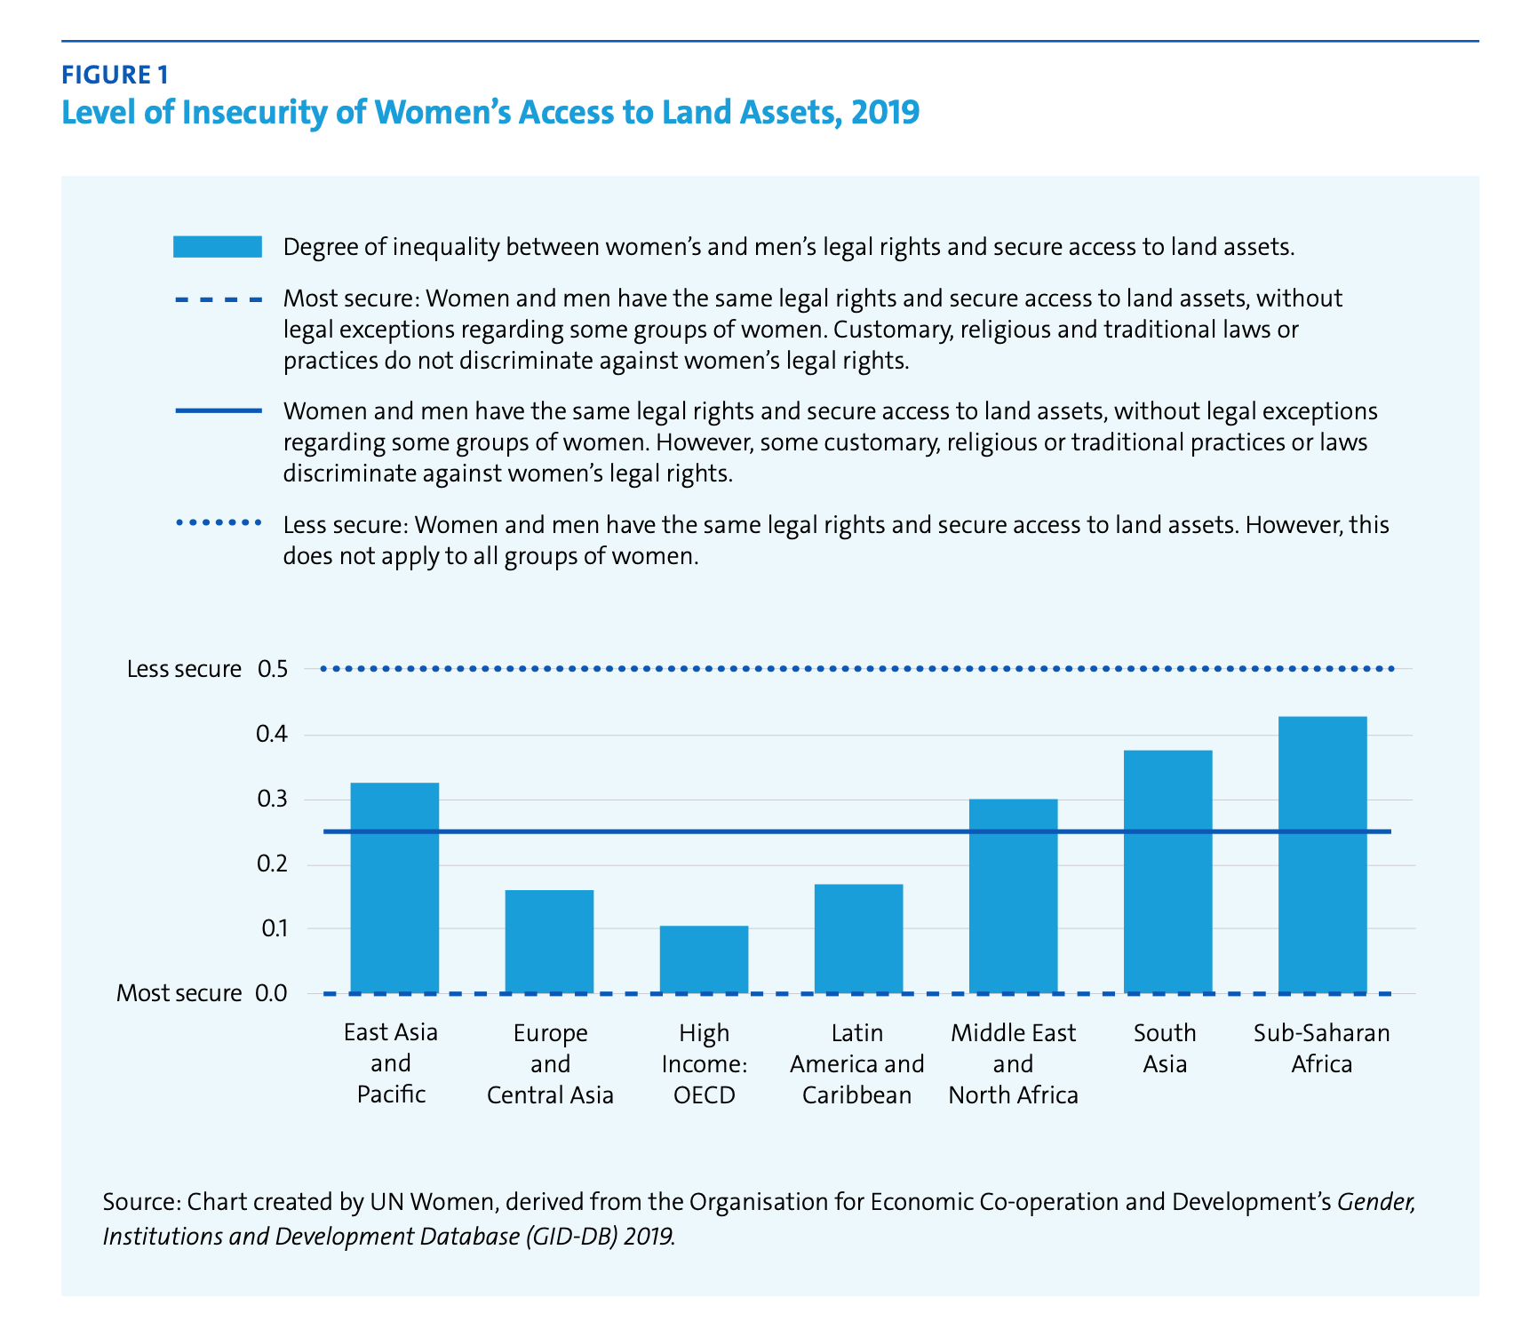

Significant gender inequalities remain in access to, use of, and control over land and other productive resources around the world. It is difficult to make generalized statements about women’s land rights, even at the regional level **(Doss et al., 2013).** However, the pattern that emerges across countries is that women consistently own less land than men, regardless of how ownership is conceptualized, and in many cases, the gender gaps are quite large **(Doss et al., 2013).** Globally, almost one-third of employed women work in agriculture, including forestry and fishing, with agriculture remaining the most important employment sector for women **(FAO, 2020a).** On the basis of an analysis of 180 countries, "164 countries explicitly recognize the right of women to own, use, make decisions and use land in a way that ensures equality with men. However, only 52 countries guarantee these rights both in law and practice because of discriminatory customary laws.” **(OECD, 2019a)**. In 9 percent of countries, women do not have the same legal rights as men to own, use, or control land (see Figure 1)

**Women’s right to land, Religion & Culture:**

Giving women equal rights to land, on the other hand, will be a violation of religious and cultural traditions regarding family law policy. Different religions have different policies, with Islam providing the greatest number of rights to women when compared to the other religions, which are characterized by the distribution of land in a 2:1 ratio between sons and daughters. As an additional point of clarification, there are many religions, such as Hinduism, in which daughters do not inherit any property from their fathers. These are based on the premise that, if women are granted equal rights to land, this would weaken the position of men in the legal system, thereby strengthening women's legal claims in the process.

There are several other factors as well that determine the promotion and protection of these rights in any society, including customs, prevailing traditions, and religious laws that govern behavioral patterns in that society. Women are culturally regarded as inferior to men, and a male-child is generally celebrated and given a larger share of property. However, in terms of property rights, the tenets of both Islam and Christianity do not disregard the woman. Culture and religion are two important factors that are frequently used to justify violations of women's rights in general. Even though both factors are separable, it is often difficult to separate them in most patriarchal societies because they are used to support each other.

**\*\*\*Eita oi against er point ta**

**Conclusion:**

Land and other productive resource rights are necessary to enjoy other human rights. All women and girls, especially those who confront several types of discrimination – such as indigenous, peasant, and rural women, displaced women, and women living in informal settlements – should be granted equal access to land rights under formal and non-formal legislation. As a result of global trends such as increased land commercialization and financialization, climate change, biodiversity loss, land degradation, and urbanization, many countries have developed national experiences and promising methods to achieve women's land rights. As a result, all initiatives to strengthen land and resource governance should use gender-responsive and human rights-based approaches, many of which have been presented herein.

**\*\*\*ei point ta include korte hobe j Against er point ta violate koetese thiki kinto you not only for the development of the women but also for the society, women should be provided with all the equal rights and opportunities to land.**